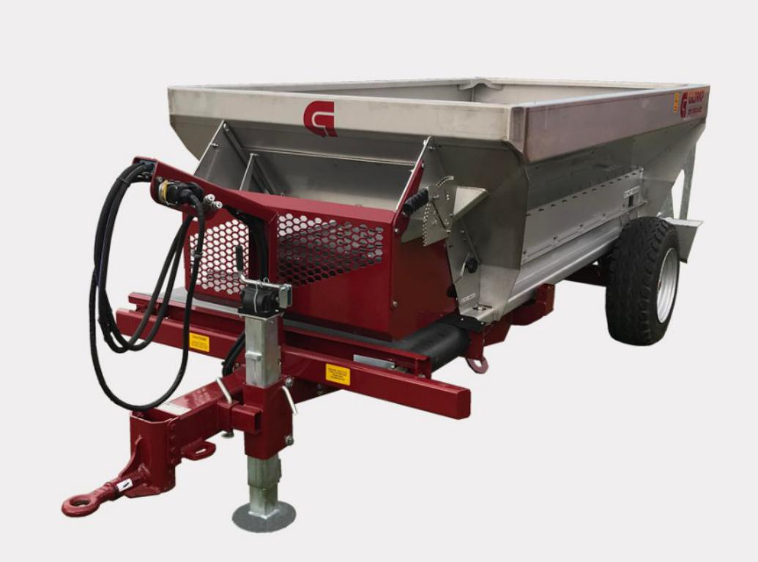
Spreading in vineyards, orchards and other horticultural settings can be difficult. With tight row spacing and sometimes limited height canopies, it's important to select the right spreader for the job.
Giltrap Orchard Spreaders belong to our Pro-Series range and are designed to handle organic matter like compost and mulch, or processed fertilisers such as superphosphate, lime and urea. Key features include a large volume Grade 304 stainless steel bin, wide belt and touch screen control for superior rate and placement control.
Choose from two models. The 3T-ORCHARD is our original popular selling machine with an endless vulcanised belt, roller bed floor and swappable rear delivery units including twin spinners and three different belt configurations for banding or piling.
Or, for the best of both worlds, the ORCHARD-MD lets you swap between rear broadcast spreading with twin spinners, or banding with the front belt in full view of the driver, with no change-over time.

Orchard MD-Spreader Specification
Length 4.80m
Width 1.66m
Height 1.45m
Bin Length 3.00m
Capacity 2.35 Cub. Metre (2t Urea)
Tare Weight 1375kg
Wheels Single Axle Tyres 10.00/75 -13.3
Oil Flow Required Min. 40lpm Max 60lpm

